|  |
| --- |
| **STUDENT NAME** |
| Alley Chaggar |

**LAB #12**

BEFORE WE START 2

ACTIVITY 1 2

ACTIVITY 2 16

# BEFORE WE START

1. Double – click on the Blender icon on your desktop.
2. Close the tutorials windows.
3. Start rendering.

# ACTIVITY 1

## DESIGNING OBJECTS AND CURVES IN BLENDER

This tutorial demonstrates how to design objects using Curves in Blender, such as Bezier Curves. The object is a cup and we are going to draw the handle using Curves.

Follow the steps below:

1. Click on the cube and then press Delete.
2. Click Layout 🡪 Add 🡪 Mesh 🡪 Cylinder.
3. Click the Add Cylinder tab and set the Cap Fill Type to Triangle Fan.
4. Click Object Mode and select Edit Mode.
5. Deselect the object, by clicking on the background.
6. Click on the Vertex select option.  
     
   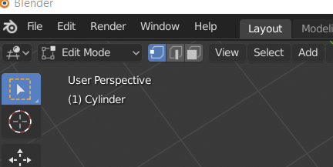
7. Click on the central cylinder vertex and select it.
8. Press Delete.
9. Select Vertices.
10. The result should be, as show below:  
      
    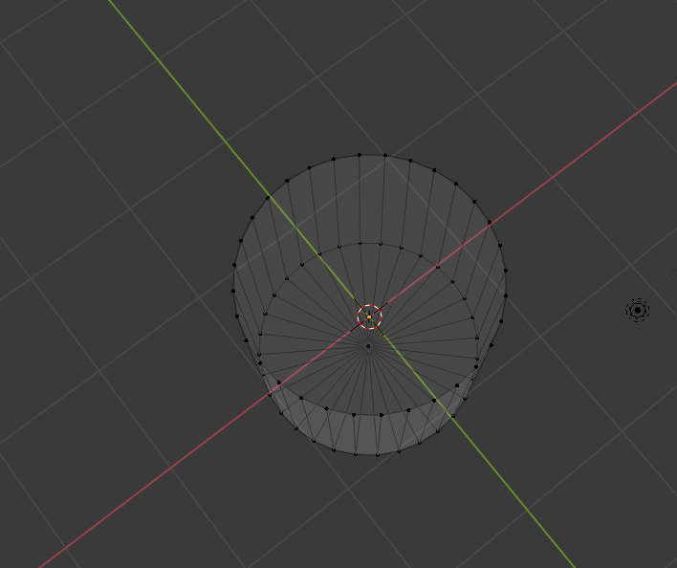
11. Click on the X axis gizmo.
12. Click on the Loop Cut tool in the tools bar or press Ctrl+R.
13. Roll up the mouse roller, creating something such as the object below:  
      
    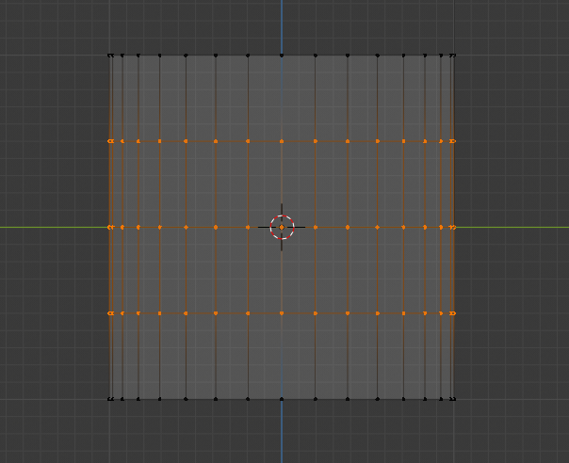
14. Press B and select the top vertices of the cylinder.
15. Click on the Move tool and move them downwards.
16. Press S and bend internally the lid, as shown below:  
      
    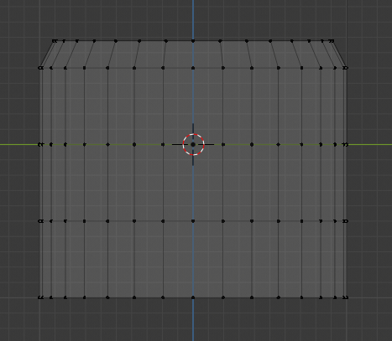
17. Re-position the camera using the middle mouse button, looking the torus from above.
18. Press B.
19. Select the middle section of the cylinder and scale it over the Y axis (green), as shown below:  
      
    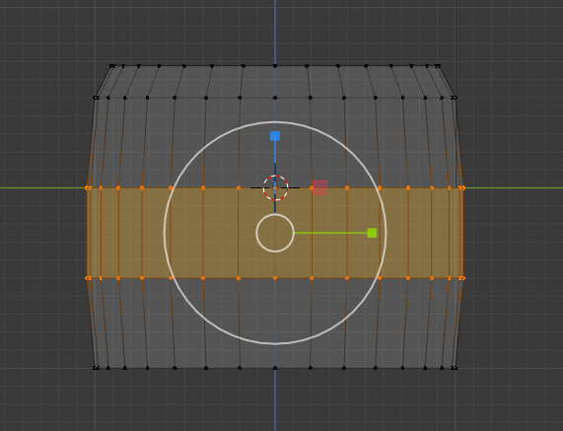
20. Select the bottom layer of vertices press S and bend them as shown below:  
      
    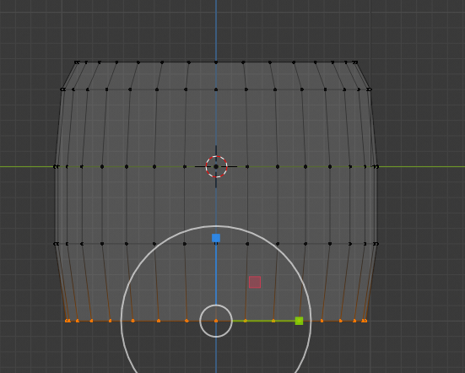
21. Set the Mode to Object Mode.
22. Set the Viewport to Viewport Shading mode, as shown below:  
      
    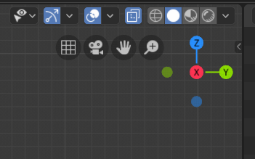

Once you complete the previous steps:

|  |
| --- |
| **TASK 1.1:**  Take a screenshot of the Viewport (and the whole screen) and paste it below: |
|  |

1. Click on the Move tool.
2. Mode the cylinder to the left side of the screen.
3. Click Layout 🡪 Add 🡪 Curve 🡪 Path.
4. Click on the NurbsPath object and rotate if need to take the below position:  
     
   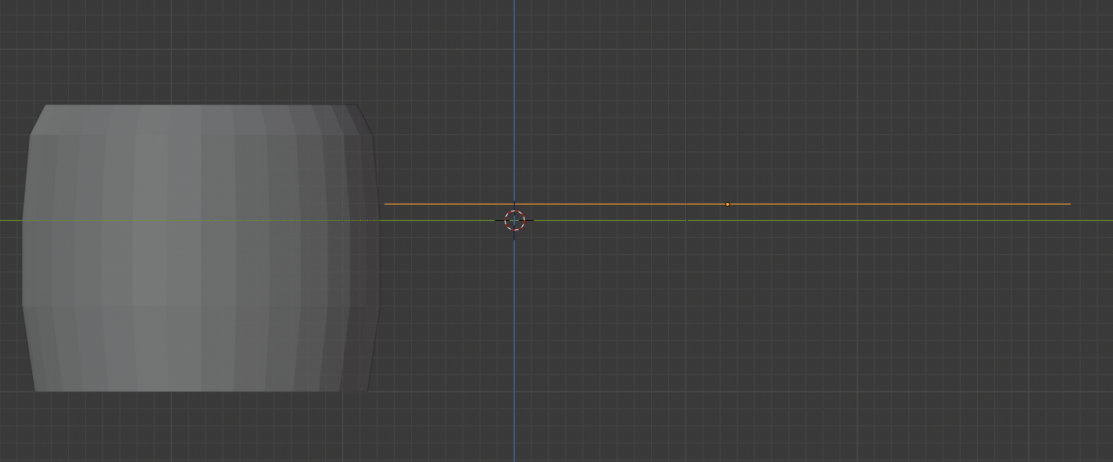
5. Switch to Edit Mode.
6. Set the points of the line as shown below:  
     
   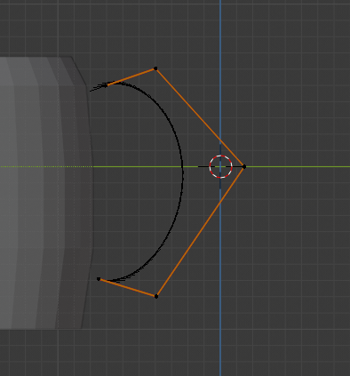
7. Then modify the points to match the image below:  
     
   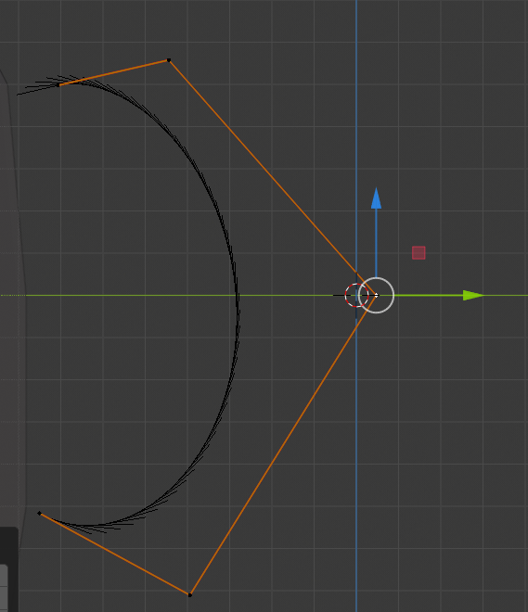
8. Click on the Layout 🡪 Add 🡪 Curves 🡪 Circle.
9. Press S and reduce the size of the circle – line.
10. Select the NurbsPath again and click at the Object Data tab, as shown below:  
      
    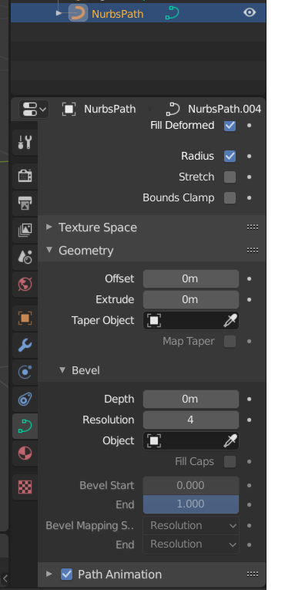
11. Expand the Geometry and then the Bevel tab.
12. Click on the Object property and select the BezierCircle object.

Once you complete the previous steps:

|  |
| --- |
| **TASK 1.2:**  Take a screenshot of the Viewport (and the whole screen) and paste it below: |
|  |

1. Click on the BezierCircle object (in the scene) and under the Geometry – Bevel tab set the Resolution to 1.
2. Click on the NurbsPath object again and right – click 🡪 Convert to Mesh.
3. In the pop-up menu select the **“Mesh from Curve, Meta, Surf, Text**” option.
4. Click on the BezierCircle and press Delete.
5. Select both object and press Ctrl+J joining them.
6. Switch to Edit Mode and select the Faces Select option.
7. Select the two Faces as shown below:  
     
   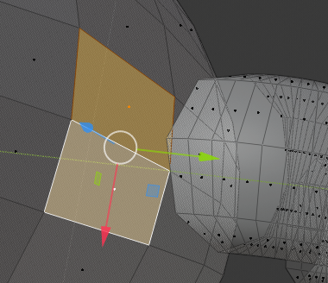
8. Press Delete 🡪 Faces.
9. Select the two faces as shown below and delete them too.  
     
   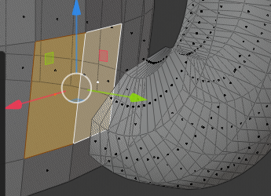
10. Pick the Edge select tool.
11. Select the Edges as shown below and press F.  
      
    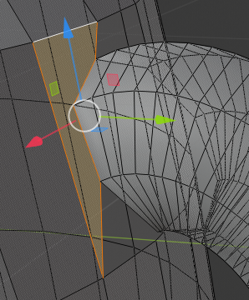
12. Repeat the same process and connect the cylinder and the curve.

Once you complete the previous steps:

|  |
| --- |
| **TASK 1.3:**  Take a screenshot of the Viewport (and the whole screen) and paste it below: |
|  |

1. Click on the Show X-Ray and Wireframe options.
2. Click on the X axis gizmo.
3. Click on the Vertices Selection.
4. Select all the Vertices on the lid as shown below:  
     
   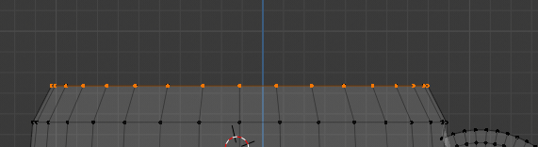
5. Click Extrude Region and then Enter.
6. Press S and type 0.8.
7. Make sure that the Vertices are still selected and press E.
8. Press and hold Z and move the cursor downwards.
9. Stop where the mug’s body curves change and increase or decrease the width of the hole pressing S and scaling.  
     
   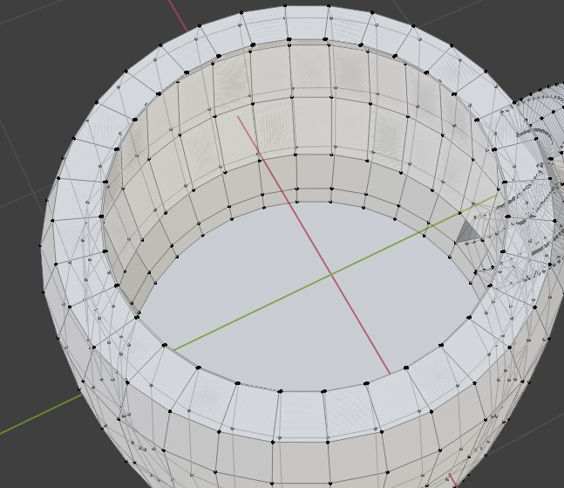
10. After repeating the process for the whole mug, press Alt+M 🡪 At the center.  
      
    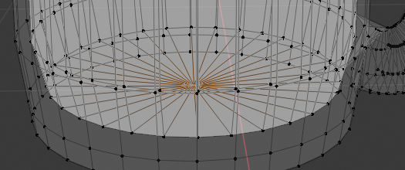
11. Set the Viewport Shading to Solid, deactivate the X-Rays.
12. Set the Mode to Object Mode.
13. Right – click on the Mug and select Shade Smooth.

Once you complete the previous steps:

|  |
| --- |
| **TASK 1.4:**  Take a screenshot of the Viewport (and the whole screen) and paste it below: |
|  |

# ACTIVITY 2

## MATERIALS

An object is not being only its color. A realistic object should be applied with a material. A Material reflect the physical qualities of an object. A metallic object is usually shiny and a fabric matte. In Blender, we can first create a material and then apply it to an object or parts of an object.

Follow the steps below:

1. . Click on the Modifier tab and select the Subdivision Surface
2. Set the Render, the Viewport and the Quality to 4.
3. Click on the Materials tab and then press the New Material button.
4. Set the settings as shown below:  
     
   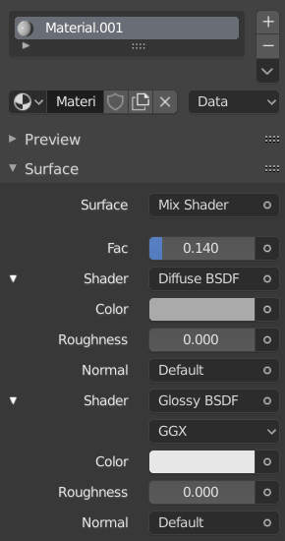
5. Scroll down to the Viewport Display and set the color to a White-Gray one and the Metallic and Roughness to 0.

Once you complete the previous steps:

|  |
| --- |
| **TASK 2.1:**  Take a screenshot of the Viewport (and the whole screen) and paste it below: |
|  |

1. Click File 🡪 Save as…
2. Save the project as Mug.blend.
3. Click File 🡪 Export 🡪 FBX (.fbx).
4. Name the file Mug.fbx and export the Selection Only.
5. Export the model.

|  |
| --- |
| **TASK 2.2:**  Locate the Mug.fbx model file and add it to the submission folder. |
| upload iconIn the LMS, add the file to the assignment Lab #12 submission folder. You can submit multiple files at a time. |

FINAL STEP: Save this document as a PDF. Upload the PDF to the Lab #12 submission folder.